**1. Write a function that takes a list of lists and returns the value of all of the symbols in it, where each symbol adds or takes something from the total score. Symbol values:**

**# = 5**

**O = 3**

**X = 1**

**! = -1**

**!! = -3**

**!!! = -5**

**A list of lists containing 2 #s, a O, and a !!! would equal (0 + 5 + 5 + 3 - 5) 8.**

**If the final score is negative, return 0 (e.g. 3 #s, 3 !!s, 2 !!!s and a X would be (0 + 5 + 5 + 5 - 3 - 3 - 3 - 5 - 5 + 1) -3, so return 0.**

**Examples**

**check_score([**

**["#", "!"],**

**["!!", "X"]**

**]) ➞ 2**

**check_score([**

**["!!!", "O", "!"],**

**["X", "#", "!!!"],**

**["!!", "X", "O"]**

**]) ➞ 0**

**ANS:** 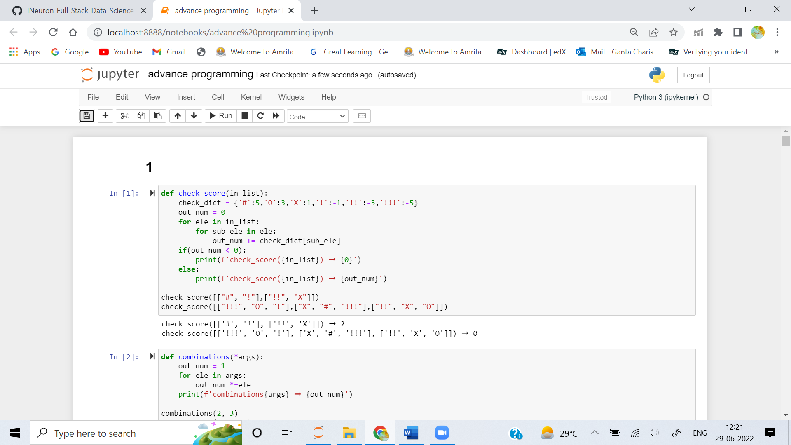

**2. Create a function that takes a variable number of arguments, each argument representing the number of items in a group, and returns the number of permutations (combinations) of items that you could get by taking one item from each group.**

**Examples**

**combinations(2, 3) ➞ 6**

**combinations(3, 7, 4) ➞ 84**

**combinations(2, 3, 4, 5) ➞ 120**

**ANS:** 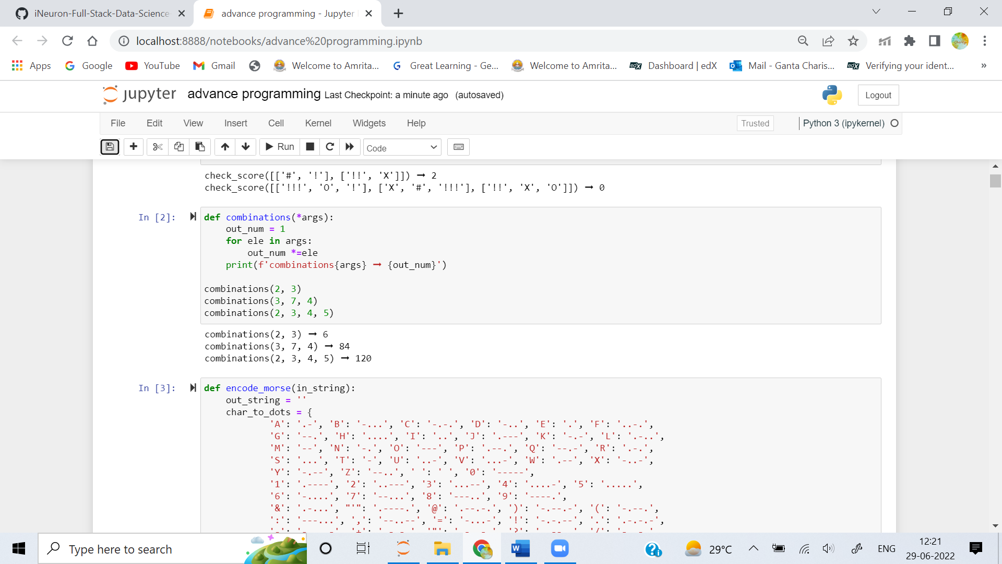

**3. Create a function that takes a string as an argument and returns the Morse code equivalent.**

**Examples**

**encode_morse("EDABBIT CHALLENGE") ➞ ". -.. .- -... -... .. - -.-. .... .- .-.. .-.. . -. --. ."**

**encode_morse("HELP ME !") ➞ ".... . .-.. .--. -- . -.-.--"**

**This dictionary can be used for coding:**

**char_to_dots = {**

**'A': '.-', 'B': '-...', 'C': '-.-.', 'D': '-..', 'E': '.', 'F': '..-.',**

**'G': '--.', 'H': '....', 'I': '..', 'J': '.---', 'K': '-.-', 'L': '.-..',**

**'M': '--', 'N': '-.', 'O': '---', 'P': '.--.', 'Q': '--.-', 'R': '.-.',**

**'S': '...', 'T': '-', 'U': '..-', 'V': '...-', 'W': '.--', 'X': '-..-',**

**'Y': '-.--', 'Z': '--..', ' ': ' ', '0': '-----',**

**'1': '.----', '2': '..---', '3': '...--', '4': '....-', '5': '.....',**

**'6': '-....', '7': '--...', '8': '---..', '9': '----.',**

**'&': '.-...', "'": '.----.', '@': '.--.-.', ')': '-.--.-', '(': '-.--.',**

**':': '---...', ',': '--..--', '=': '-...-', '!': '-.-.--', '.': '.-.-.-',**

**'-': '-....-', '+': '.-.-.', '"': '.-..-.', '?': '..--..', '/': '-..-.'**

**}**

**ANS:** 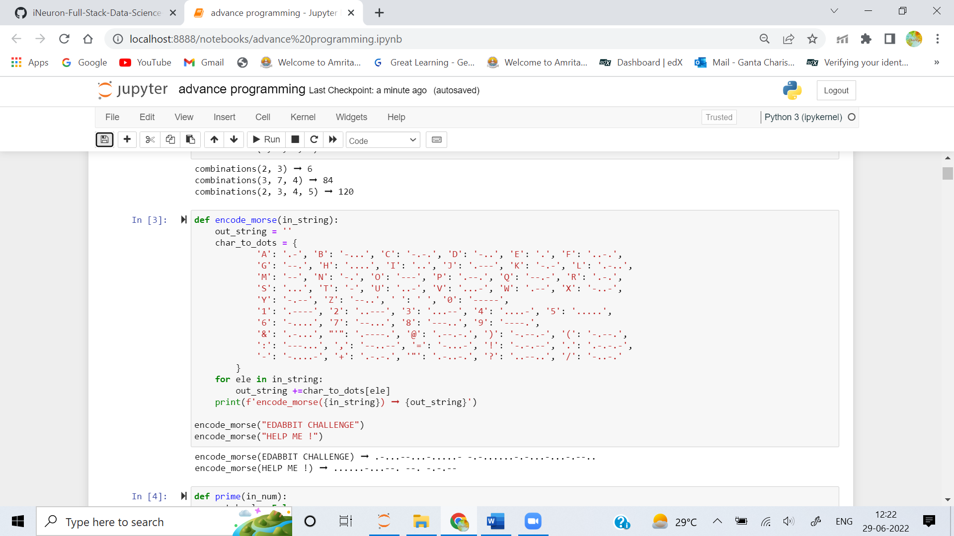

**4. Write a function that takes a number and returns True if it's a prime; False otherwise. The number can be 2^64-1 (2 to the power of 63, not XOR). With the standard technique it would be O(2^64-1), which is much too large for the 10 second time limit.**

**Examples**

**prime(7) ➞ True**

**prime(56963) ➞ True**

**prime(5151512515524) ➞ False**

**ANS:** 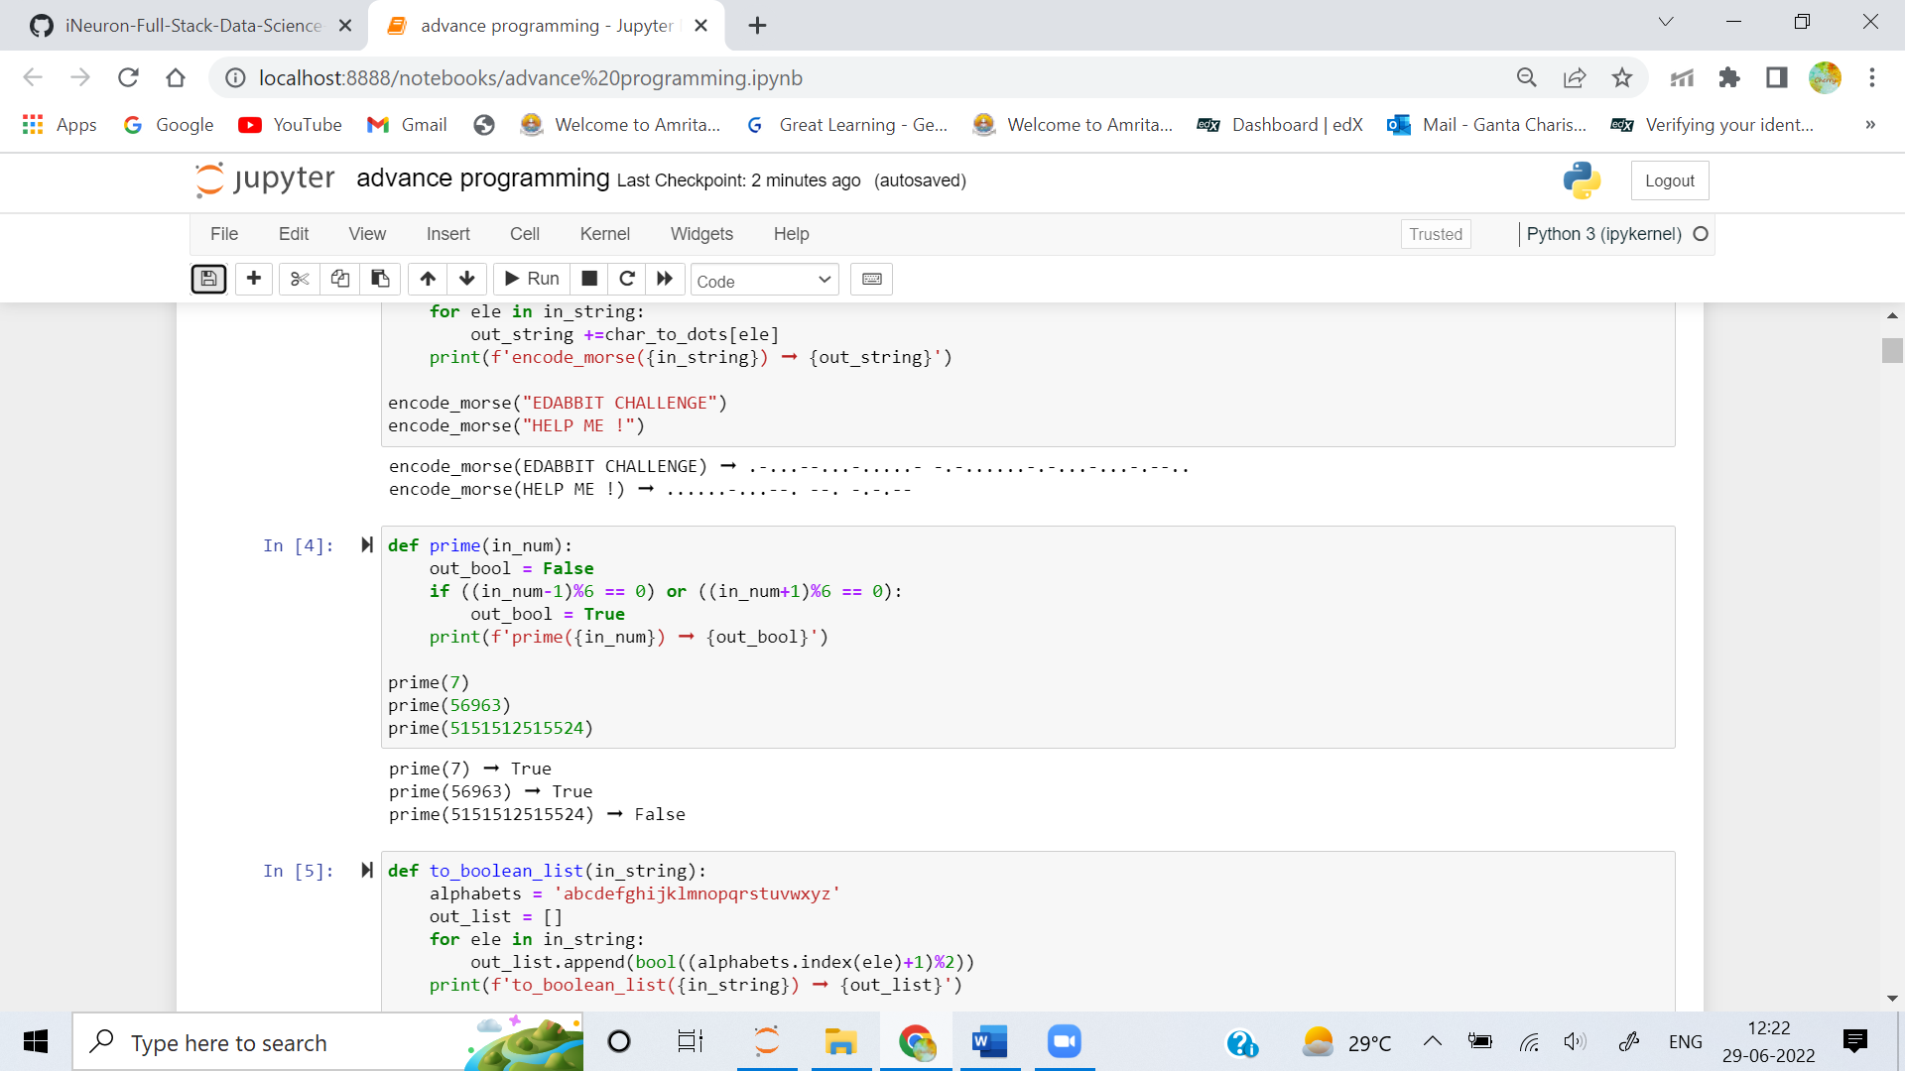

**5. Create a function that converts a word to a bitstring and then to a boolean list based on the following criteria:**

**1. Locate the position of the letter in the English alphabet (from 1 to 26).**

**2. Odd positions will be represented as 1 and 0 otherwise.**

**3. Convert the represented positions to boolean values, 1 for True and 0 for False.**

**4. Store the conversions into an array.**

**Examples**

**to_boolean_list("deep") ➞ [False, True, True, False]**

**# deep converts to 0110**

**# d is the 4th alphabet - 0**

**# e is the 5th alphabet - 1**

**# e is the 5th alphabet - 1**

**# p is the 16th alphabet - 0**

**to_boolean_list("loves") ➞ [False, True, False, True, True]**

**to_boolean_list("tesh") ➞ [False, True, True, False]**

**ANS:**

